Lalit Patil

243526

Cloud Assignment 15 March

Q1

In your Github account, create a new repository ‘linux_assignments’

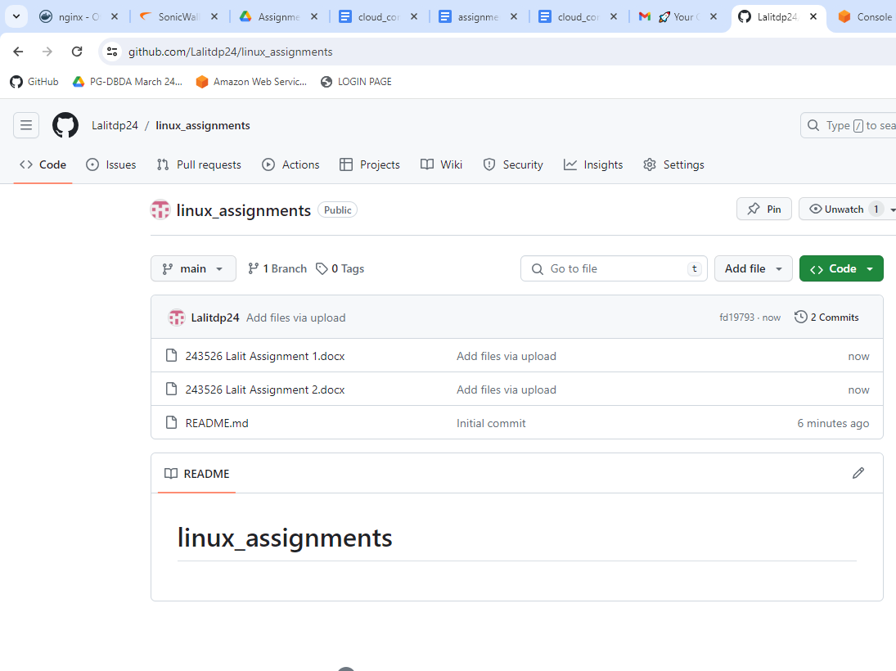

Put all the docx/pdf file solutions for your linux assignments in that folder

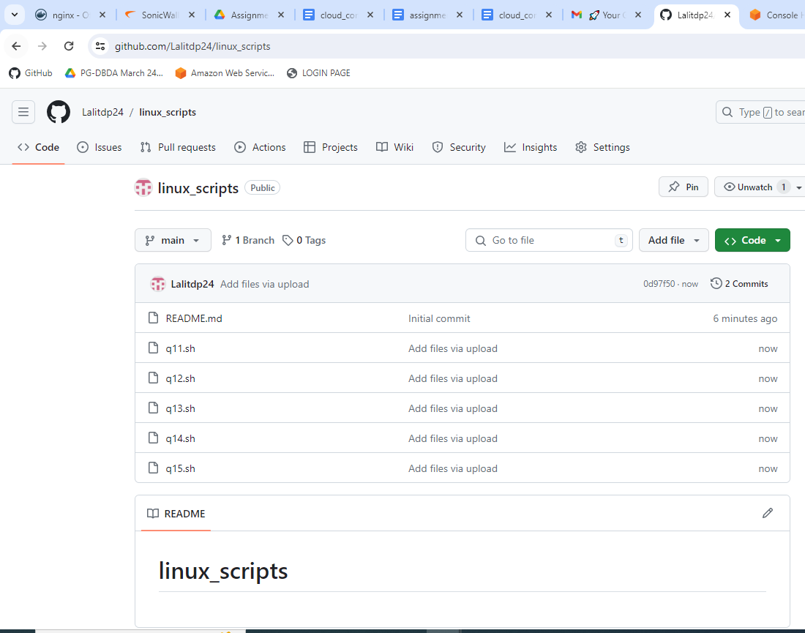

Q2 In your Github account, create a new repository ‘linux_scripts’. Put at least 5 .sh files in that folder.



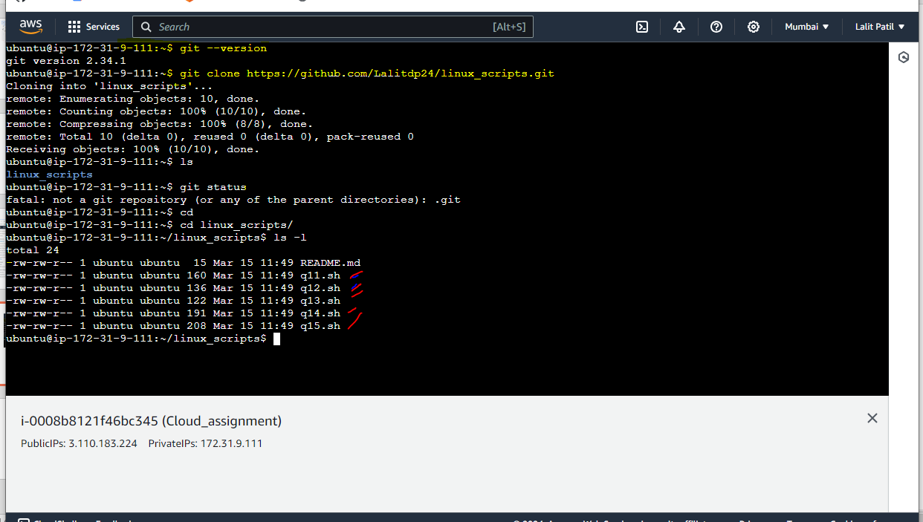

Q4 Login to AWS console. Create a new instance of EC2 with Ubuntu. On this instance install git

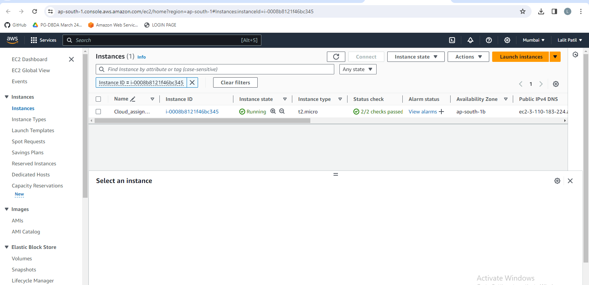

Q4 : Scripts ran on AWS EC2 instance

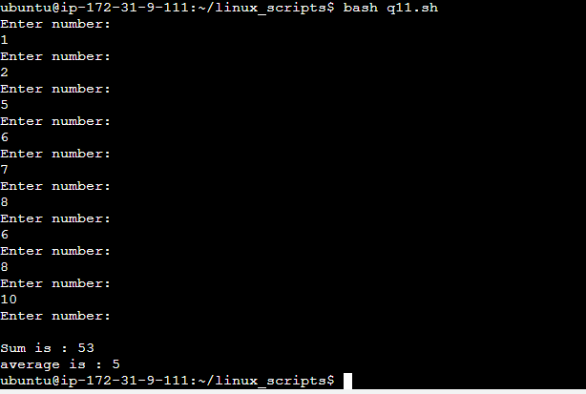

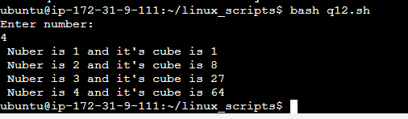

Q5 New repository created

